Scholarship Fund
Application

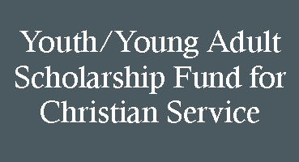

Providing scholarships to encourage and enable youth and young adults of First Presbyterian Church of Newhall to participate in Christian service.
Purpose:
First Presbyterian Church of Newhall
24317 Newhall Ave.; Newhall, CA 91321
(661) 259-0555 e-mail: presby2@pacbell.net

Scholarship Fund Application

Name:
Name: ___________________________________

Address: ___________________________________

___________________________________

Anticipated Graduation Year: ________

School: ___________________________________

Home Phone: ______________________

Cell: ______________________________

Email: __________________________________

Type of Service:____________________

__________________________________

Organization_______________________

Where:____________________________

When:_____________________________

Please complete application and leave in the church office Youth Committee mailbox.
Name: ___________________________________

Address: ___________________________________

___________________________________

Anticipated Graduation Year: ________

School: ___________________________________

Home Phone: ______________________

Cell: ______________________________

Email: __________________________________

Type of Service:____________________

__________________________________

Organization_______________________

Where:____________________________

When:_____________________________

Please complete application and leave in the church office Youth Committee mailbox.

Address:

School: Anticipated Graduation Year:

Home Phone: Cell Phone:

Applicant’s e-mail:

Parent’s e-mail:

Type of Service:

Organization:

Where: When:

Cost:

Please complete application and leave in the church office Youth Committee mailbox or e-mail to J.Vannini@yahoo.com

Scholarship Fund
Application

